THEORY QUESTIONS

PART I

MAP SKILLS AND THE ENVIRONMENT
1.
Use the map of Tamo to answer Question 1
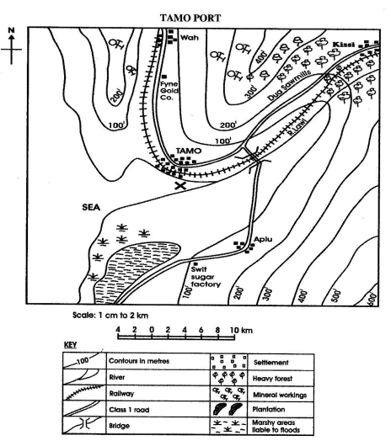
a)

What is the direction of Kissi from Tamo?
b)

Calculate the distance in kilometres along the class one road from Aplu to the bridge across River Lawi
c)

What is the direction of flow of River Lawi?
d)

Name the feature marked X at the mouth of River Lawi
e)

Mention the main two lines of communication of the area.
f)

Using the map only, name two products that are likely to be exported through the Tamo port.

2.
a)

Name three types of rainfall
b)

With the help of a diagram describe how any one type of rainfall is formed.

PART II

NATIONAL COMMUNITY
3.
a)

Mention four qualities that made Osei Tutu a good ruler of the Asantes
b)

What three things did Osei Tutu do to keep the Asantes united?

4.
a)

Mention four sources from which fish are caught in Ghana.
b)

Describe two ways by which the fish are caught.
c)

Name:
i)

two types of fish caught.
ii)

two methods of preserving fish.

PART III

WEST AFRICA, AFRICA AND THE WORLD
5.
a)

What was the major activity which brought foreigners into West Africa?
b)

What four effects did the coming of the foreigners have on the lives of the people of West Africa?
6.
a)

Mention five achievements of the Aborigines Rights Protection Society (A.R.P.S)
b)

Give five reasons why the Aborigines Rights Protection Society collapsed.

